**NST41081 Secure Network Infrastructure**

Continuous Assessment 1

Submission date 30/11/2022

Submission guideline:

Mark your registration numbers clearly in your assessment files and forward it to

razmik@gmail.com with the subject “NST41081 assessment1 - <your registration number>” on

or before the deadline.

You are a network security manager of a company MyTechWorld Pvt limited. Currently all your users are accessing internet using Network Address Translation (NAT) configured on the edge router. Your company decided to implement a web proxy server to enhance the security.

Explain how a proxy server will improve the security

* A proxy server act as both a firewall and a filter. A proxy for data and privacy protection can be chosen by the end-user or a network administrator. The data entering and leaving your computer or network is examined in this way. Then, laws are put into place to stop you from having to reveal your digital address to the public. By hackers or other bad actors, just the proxy's IP address is visible. Internet users cannot directly access your personal files, schedules, apps, or data without knowing your personal IP address.

When it's active, web requests are routed through the proxy, which then connects to the internet and retrieves your desired content. Passwords and other sensitive data are further protected if the server has encryption capabilities.

* Use several proxies for private browsing, viewing, listening, and purchasing to assist you avoid being assaulted with advertisements or the gathering of IP-specific data.
* Access to geographic content: You can choose a proxy server with a local IP address from another nation. You may, in essence, make it appear as though you are in that nation, giving you complete access to any and all of the information that computers in that nation are permitted to interact with.
* Stop your staff from visiting inappropriate or distracting websites: It may be used to restrict access to websites that violate the values of your company. Additionally, you may restrict websites that frequently cause workers to become away from crucial duties. To eliminate temptations to waste time, several firms restrict social media sites like Facebook and others.

Assuming the below network setup, select a suitable network location to place the proxy server and justify the reason for your selection.

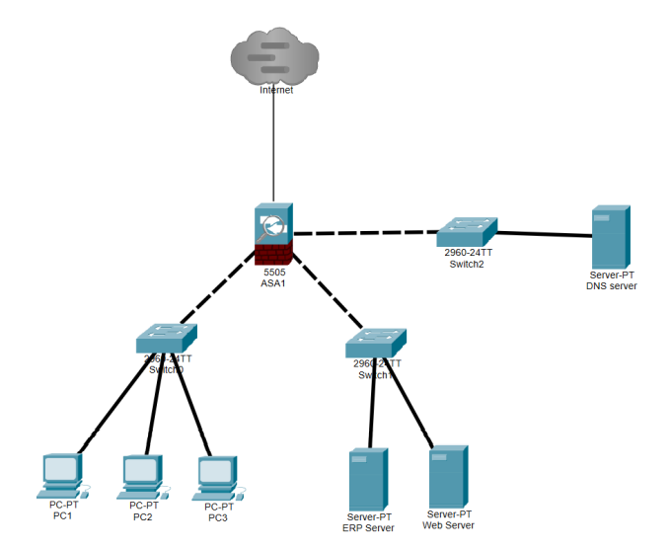

I'm putting the proxy server **between the internal switch and the firewall**.

The proxy server will have an outside (Network A) and an internal (NIC) card (Network B). As a result, the internal vlans will have a proxy server as their gateway and will be routed through it. If the traffic is going to the internet, Network B will be NATted with Network A and then Network A will be NATTED AGAIN with the WAN IP address on the firewall.